**LILYDALE PRIMARY SCHOOL**

**SCHOOL PHILOSOPHY POLICY**

At Lilydale Primary School we believe in developing the whole child and supporting them as they continue their educational journey. We encourage our students to achieve their best and support them with programs that develop them as individuals academically, socially, creatively and physically. We value individuality and understand that each child has their own learning needs, their own aspirations and learning journey.

Our students are always at the centre of our thinking when we implement school policies, practices and when creating teaching and learning programs. As a school community we work together to provide the opportunities and programs that will support their development as contributing members of our community.

Our mission statement and agreed school values support our students to develop a sense of self-worth, mutual respect for their peers, their teachers and their family, responsibility for their own actions and learning and perseverance when facing challenges.

We value our community and encourage parents, friends and community members to take an active role in our school. We develop relationships with other schools, child care facilities, Preschools, the local council and local businesses to foster an understanding in our students about the importance of community and citizenship.

We actively promote student leadership and encourage our students to lead school events and identify charitable causes that we can support. We encourage our students to have opinions and to share these with the school as a whole

We meet regularly as a whole school to reinforce our school values and celebrate our students’ achievements. We believe that each individual student can achieve great progress and we encourage our students to try their best in all they do.

**Mission Statement**

Through reflective and collaborative practices, we will create a positive, safe, and inspiring learning environment that promotes a strong sense of community and ensures child-focused decision making to develop confident, motivated and aspirational students who enjoy learning

**Vision Statement**

At Lilydale Primary School our students will grow to be strong respectful individuals, they have an understanding of their ability to educate and empower each other as well as themselves. Our students learn to be kind, caring, creative and inspired.

**School Values**

The Lilydale School Values are based on PRIDE in our School. The values are Perseverance, Respect, Inclusion, Determination and Encouragement. These values are embedded into the school through its curriculum and interactions between stakeholders. We promote the values in the wider community and involve all our stakeholders in the development of our Educational vision, Mission Statement and Values.

The programs of, and teaching in, the school will support and promote the principles and practices of Australian democracy including a commitment to:

* An elected government.
* The rule of law.
* Equal rights for all before the law.
* Freedom of religion.
* Freedom of speech and association.
* The values of openness and tolerance.

**Lilydale Primary School Core Principles**

**Lilydale Primary School believes strongly in upholding the Principles of Learning and Teaching (DEECD Guidelines) which include that the:**

* Learning environment that is supportive and productive
* Learning environment promotes independence and self-motivation
* Student needs, backgrounds, perspectives and interests are reflected in learning program
* Students are challenged and supported to develop deep levels of thinking and application
* Assessment practices are an integral part of teaching and learning
* Learning connects strongly with communities and practice beyond the classroom.

Statements which affirm the school’s core principles are found in the mission statement of the school and in documents such as the parent information booklet, the school website, the school newsletter and school letters.

**Enactment of school philosophy.**

The enactment of this policy is seen in all documents, in all practice by students and teachers, in work with the School Council and the community, in all teaching and learning programs, in all school initiatives, in all internal and external interactions and in all organisational structures and practices.

The mission of the school will sit at the centre and there will be expectations about all work aligning with the school vision and values. Regular evaluation processes will be in place to measure performance in all areas of the school with respect to the implementation of the mission statement and the values of the school.

The process at our school can be represented as the student at the centre supported by the Mission Statement, Values and Principles of Learning and Teaching and our community. A detailed list of school policies will sit within this framework.

Respect

Honesty

Perseverance

Fun

Responsibility

Mission Statement

Values

**FISO ( Framework for Improving Student Outcomes)**

The enactment of this policy will also be supported by the Framework for Student Outcomes which has Student Achievement, engagement and wellbeing at its centre

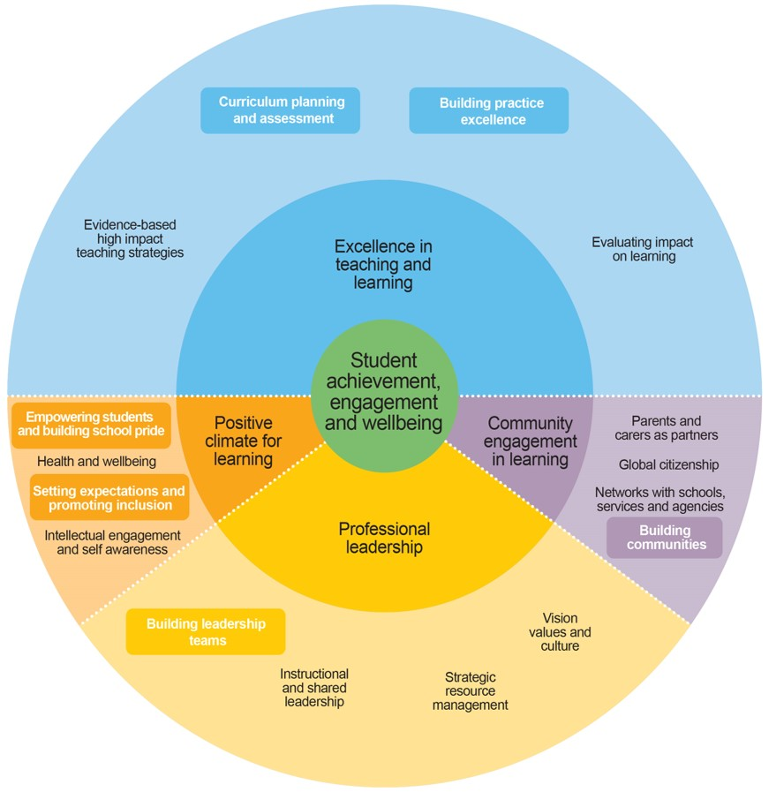

|  |  |
| --- | --- |
| Policy last reviewed | Created 18th March 2021 |
| Approved by | By School Council on 4th May 2021 |
| Next scheduled review date | March 2025 |